Results of the Q1 Question Inventory
(106 Responses Total)
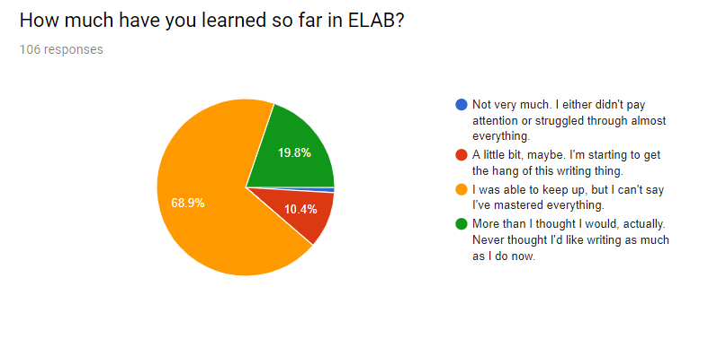
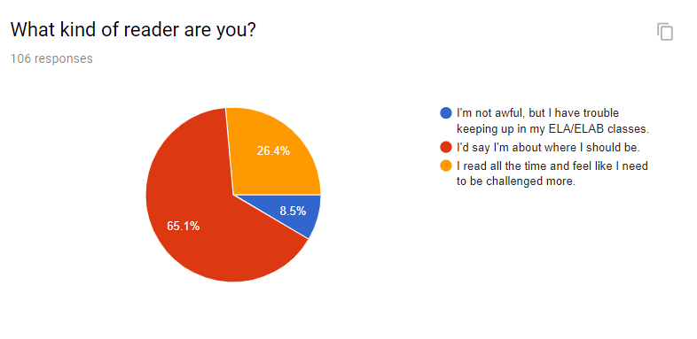
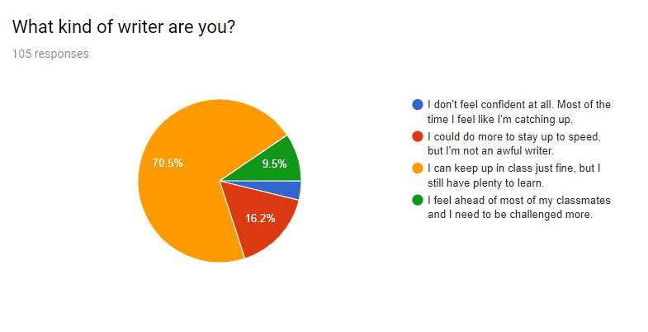
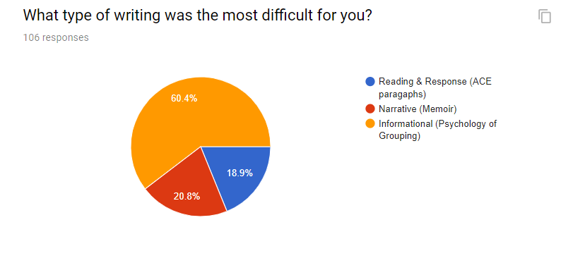
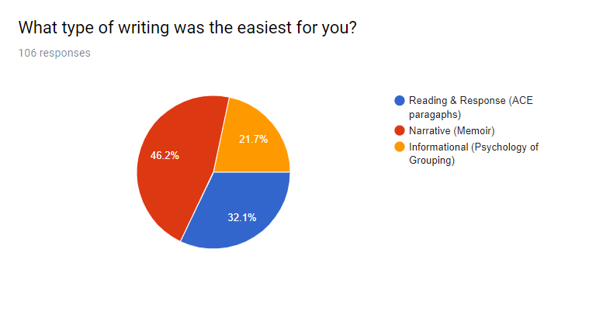
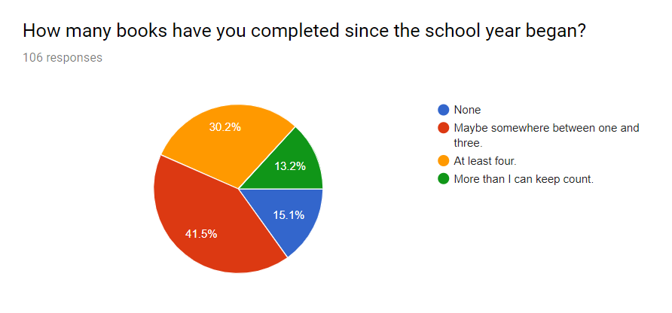

What specific skills do you think are the most difficult for you to master?
Top Three:
- Using the plot pyramid in narrative writing (44.3%)
- Writing concluding paragraphs (41.5%)
- Using flashback in narrative writing (40.%)

What specific skills do you think are the easiest for you to master?
Top Four:
- Creating a thesis (56.6%)
- Using transition words & phrases (54.7%)
- Writing topic sentence (54.7%)
- Using dialogue in narrative (54.7%)

